20-11-2019

|  |
| --- |
| MAPAS CONCEPTUALES | BRANDON GONSALES |

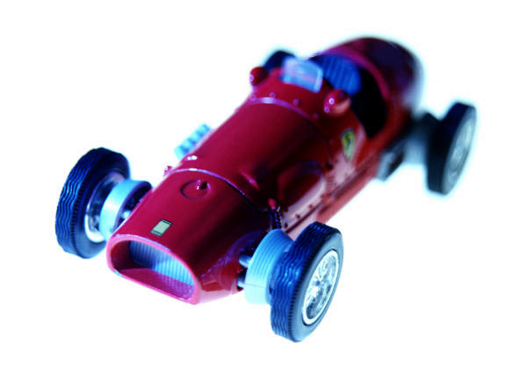

|  |  |
| --- | --- |
| CÍVICA | ACTIVIDAD EVALUATIVA |